# Acceptance Testcases

Name: Create new client

Trigger: User Interaction with CMS window

Precondition: Assert that user has logged in

Path:

1. User clicks on Admin on navigation bar
2. User clicks on Clients in the dropdown
3. User clicks “New Client” button
4. User fills the client information in the form
5. User clicks “Create Client” button
6. Client successfully created massage is shown
7. User selects “back” to return Client page

Requirements:

1. The new client’s data should be added to the database

2. The new client’s information should be displayed in the homepage correctly

3. The clients’ information should be listed in the creation order

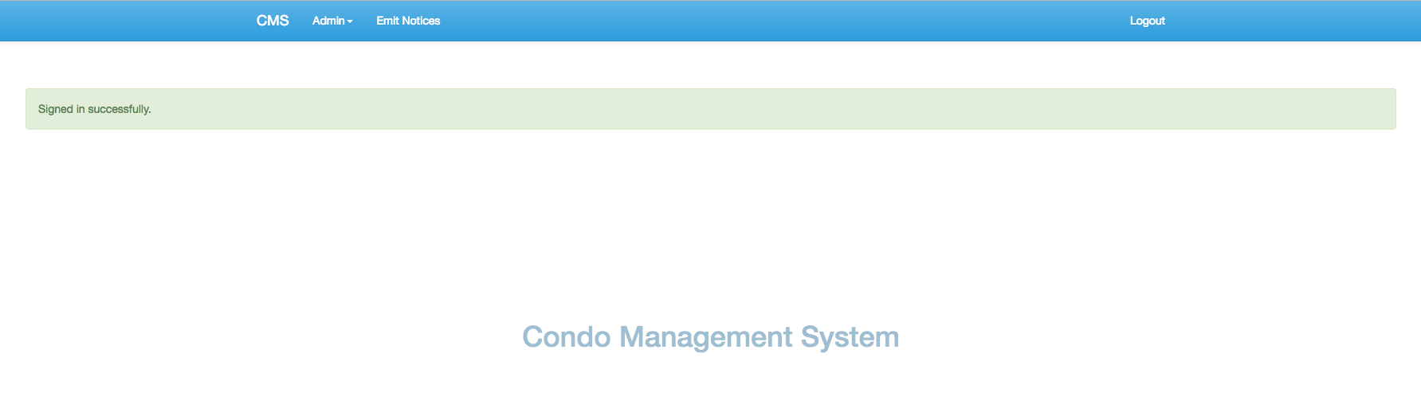

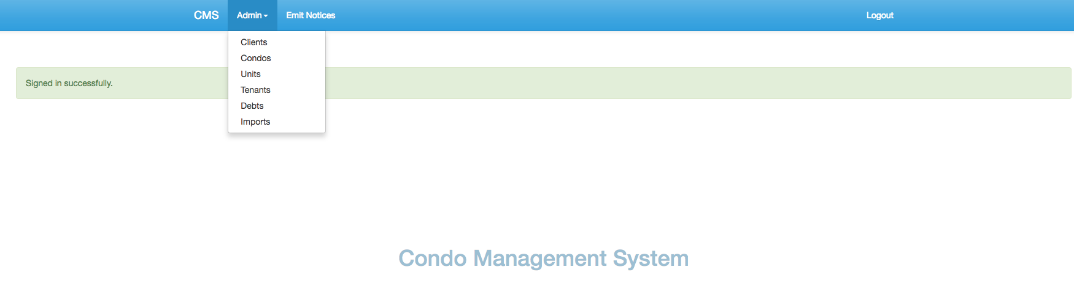

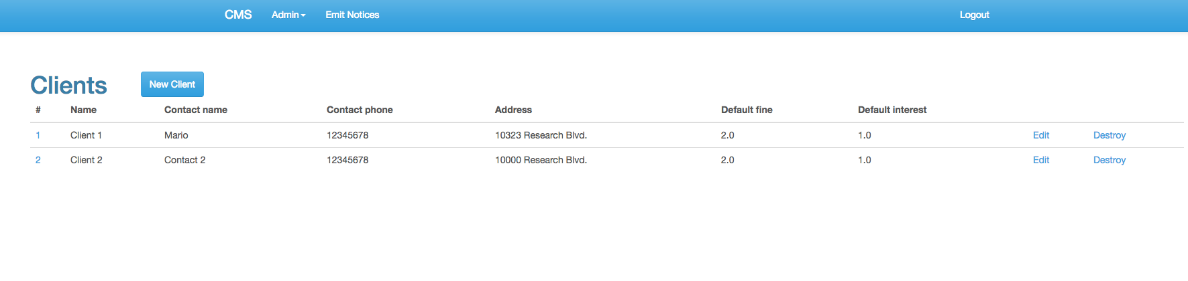

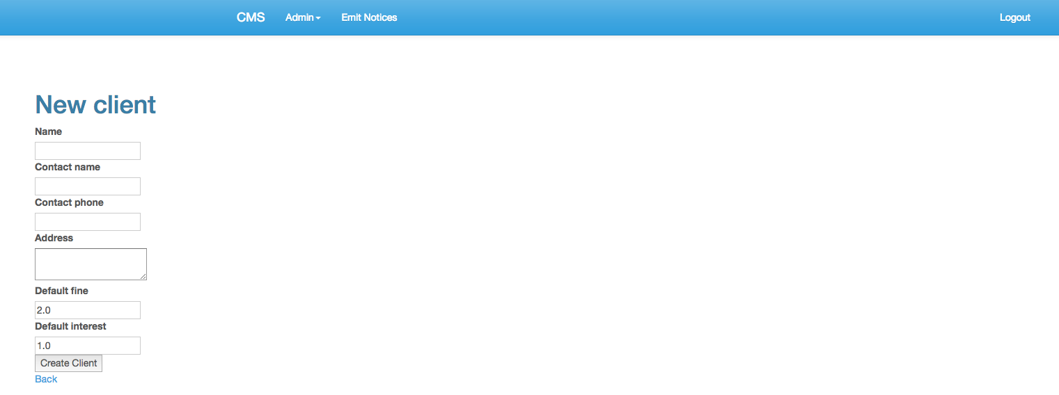

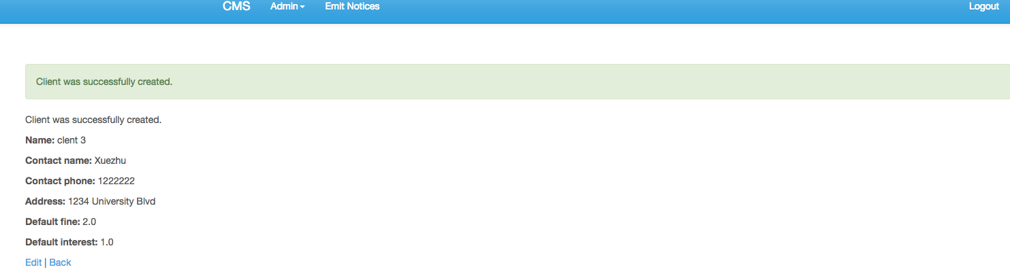

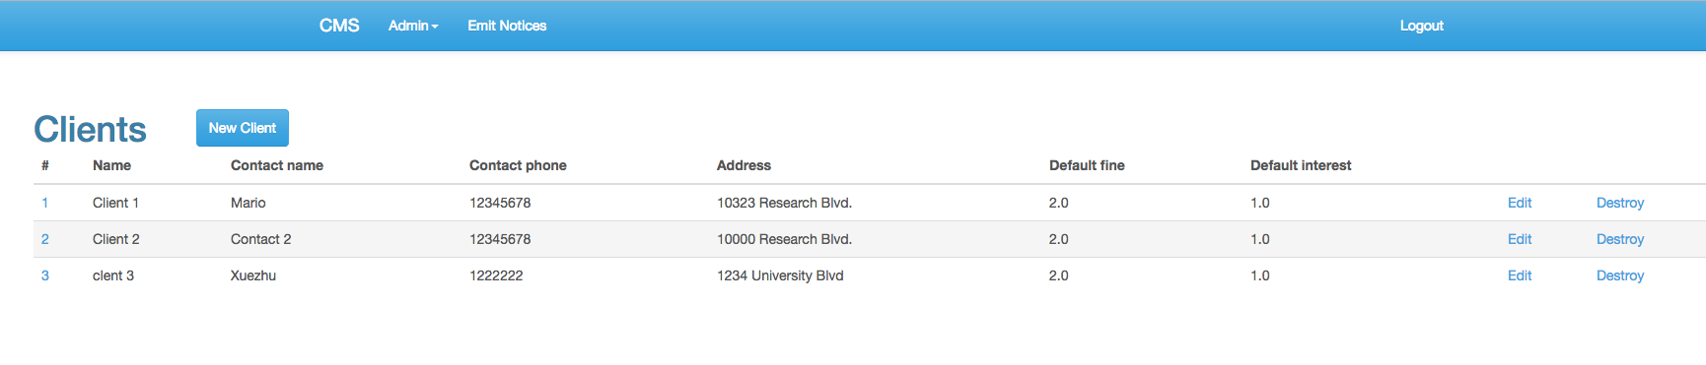

Name: Edit a client

Trigger: User Interaction with CMS window

Precondition: Assert that user is in the Client page and the client to edit is existed

Path:

1. User clicks on Edit behind the information of the client who will be edited
2. User edit new information in the form
3. User clicks “Update Client” button
4. Client successfully updated massage is shown
5. User selects “back” to return Client page

Requirements:

1. The updated client’s new data should be updated to the database

2. The updated client’s new information should be displayed in the homepage correctly

3. The clients’ information should be listed in the modification order



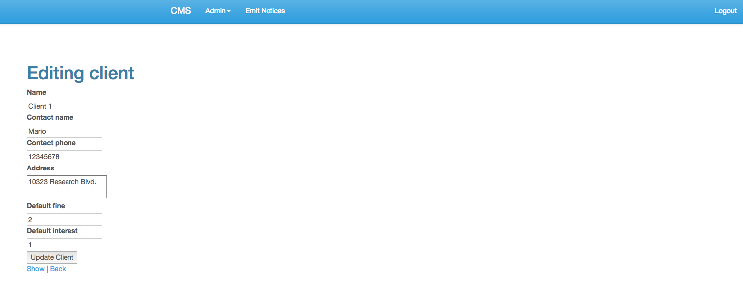

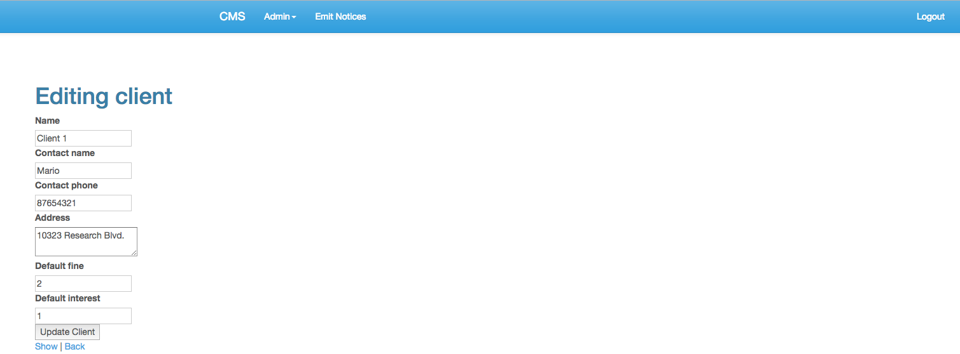

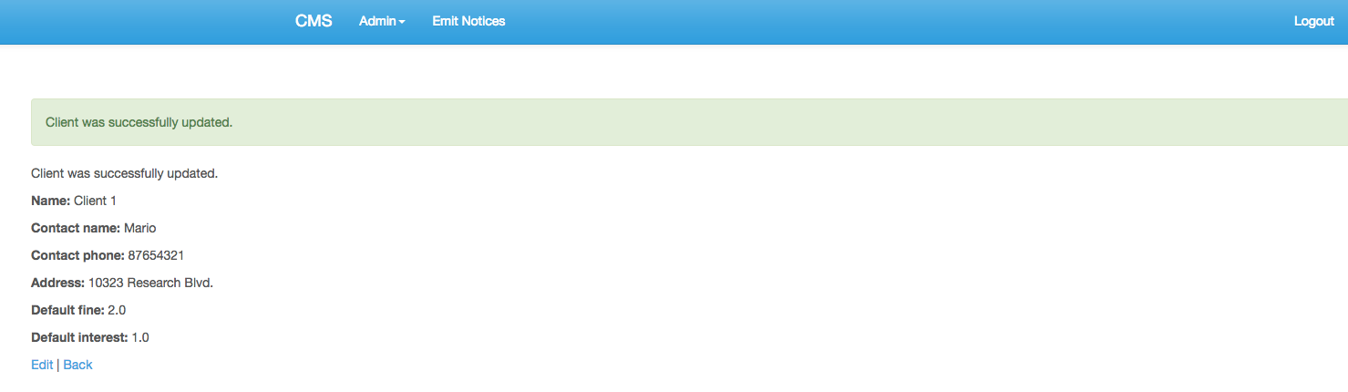

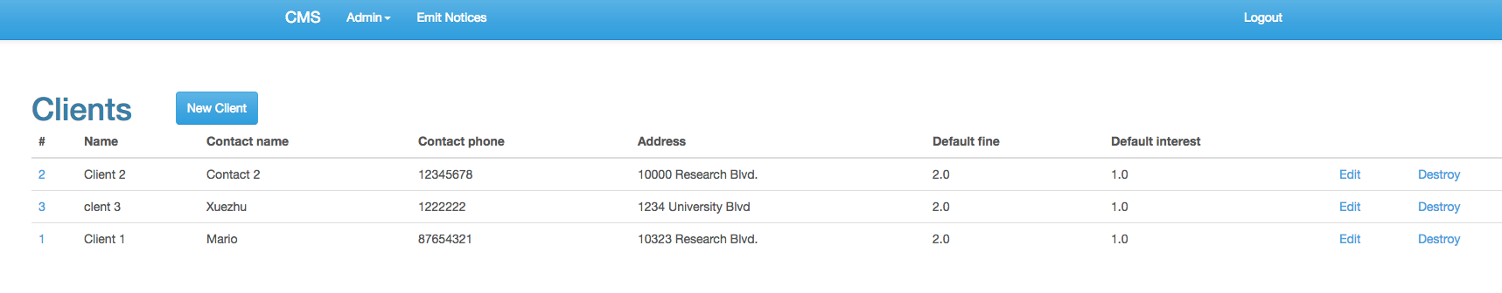

Name: Delete a client

Trigger: User Interaction with CMS window

Precondition: Assert that user is in the Client page and the client to delete is existed

Path:

1. User clicks on Destory at the end of the information of the client who will be deleted
2. An alter message says “Are you sure” is shown
3. User clicks “OK” button
4. Client successfully destroyed massage is shown

Requirements:

1. The deleted client’s data should be removed to the database

2. The deleted client’s information should not be displayed in the homepage

3. Other clients’ information should be listed as the same as those before deleting

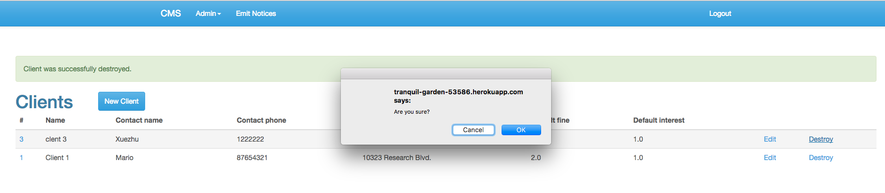

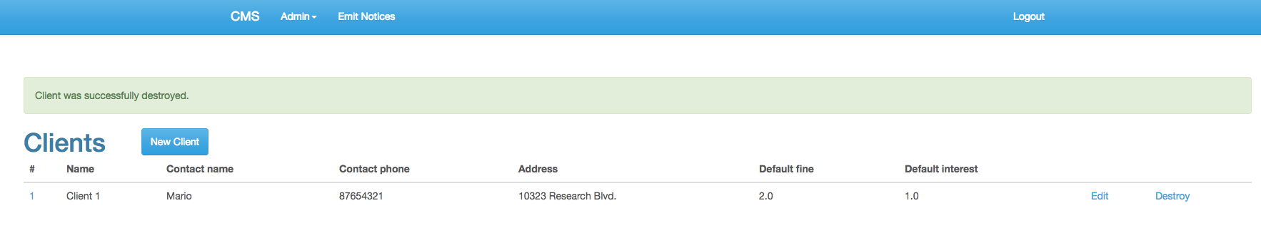

Name: Create new tenant

Trigger: User Interaction with CMS window

Precondition: Assert that user has logged in

Path:

1. User clicks on Admin on navigation bar
2. User clicks on Tenants in the dropdown
3. User clicks “New Tenant” button
4. User fills the tenant information in the form
5. User clicks “Create Client” button
6. Client successfully created massage is shown
7. User selects “back” to return Client page

Requirements:

1. The new client’s data should be added to the database

2. The new client’s information should be displayed in the homepage correctly

3. The clients’ information should be listed in the creation order

